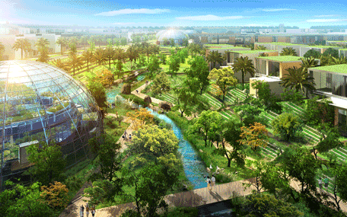n

**WADE ENERGY**

Building science with an energy engineering approach.

Wade Energy started in 2011 with a single light bulb that was going to revolutionize the world. That light bulb was an LED T8 lamp. Over the last 4 years we have shifted our focus away from product and into energy consulting, were we could be a serviced based business.

Starting with Title-24 energy code compliance in California in 2012, the company worked hard to offer the best service and fastest turnaround times. As we have been growing, our services and team have as well. We have members currently pursuing LEED accredited professional recognition for building design and construction, as well as existing buildings operation and maintenance. We focus primarily on the energy modelling portion of these projects, but have the skills and expertise to also see a project through as project managers.

In June of 2014 we introduced a third leg to the Wade Energy consulting services, which is Energy Engineering. This service brings out the design and implementation skills of the Wade Energy team. We have members with a background in clean energy engineering, and passive solar design. Within the energy engineering field there is additional analysis that we perform that will help our clients achieve a more sustainable future.

Visit us at www.wadeenergy.com to explore opportunities and learn about our team and experience.

+ **About Us**

**Title-24 Energy Reports**

**LEED Energy Modeling**

**LEED AP: BD+C & EBOM**

**Energy Engineering**

# **Our Services**

## Bringing value to your projects.

**Title-24 Documentation**

* New Construction Residential projects
* Additions and Alterations for residential projects
* New Construction Non-Residential projects
* Lighting, Mechanical, Envelope Alterations for nonresidential projects

**LEED Projects + Building Science**

* LEED Energy Modeling and templates
* LEED AP Building Design + Construction
* LEED AP Existing Building O&M
* ASHRAE Level I & II Energy Audits
* Measurement and Verification
* Mechanical Systems Analysis

**Energy Engineering**

* Clean Energy Engineering
* Passive Solar Design
* Energy Project Feasibility Studies
* Life-Cycle Analysis

**Contact Us**

Wade Energy wants to add value to your projects by partnering with you. Please one of us at:

**Travis Wade**

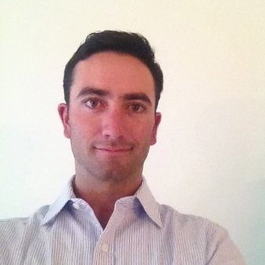

Email: travis@wadeenergy.com

**Wendy Lee**



Email: wendy@wadeenergy.com

**Nick Mott**



Email: nick@wadeenergy.com

**Randall Frisk**



Email: randall@wadeenergy.com